### **WELCOME TO LAAMIKA DESIGN STUDIO**

We provide an exclusive bespoke range, curating the latest trends as per your taste and style.

# **We are a creative group  of people who design  influential brands and  digital experiences.**

MORE ABOUT US

SCROLL DOWN

### **HELLO THERE**

# **We Are Glint**

We have arrived with the latest heart throbbing range of party wears for both men and women. Exclusive bespoke with superior quality fabrics, in the desired colors and works. Just wait a while, and we guarantee you with a perfect outfit that will suit your taste and trend.127

### **WHAT WE DO**

# **Lets put up our hands in the air and get crazy b’coz its party time!!!**

### **Brand Identity**

Laamika Design Studio dedicates its soul to all fashion lovers, who wishes to look awesome, adorable and astounding. We are mainly catering those sizes which lies in midways or plus way.

### **Services**

We fish out the latest trends in fashion and colors for you , and customize a pretty dream dress suitable to your taste. “ITS ALL ABOUT YOU” is our mantra.

### **Style advisor**

Not to worry peeps… whether you are stout or buff , tall or short , doesn’t matter with your age , color or gender! We are happy to help in cultivating your personality in fashion and let you take the spot light.

### **Right fits**

If you are worried about the fitting, then it is time to wrap it up and thrash it in the store. We tailor our designs to your given sizes and choices, and deliver a heart melting outfit at your door step.

### **RECENT WORKS**

# **Let’s go gaga and check out some of our latest designs**



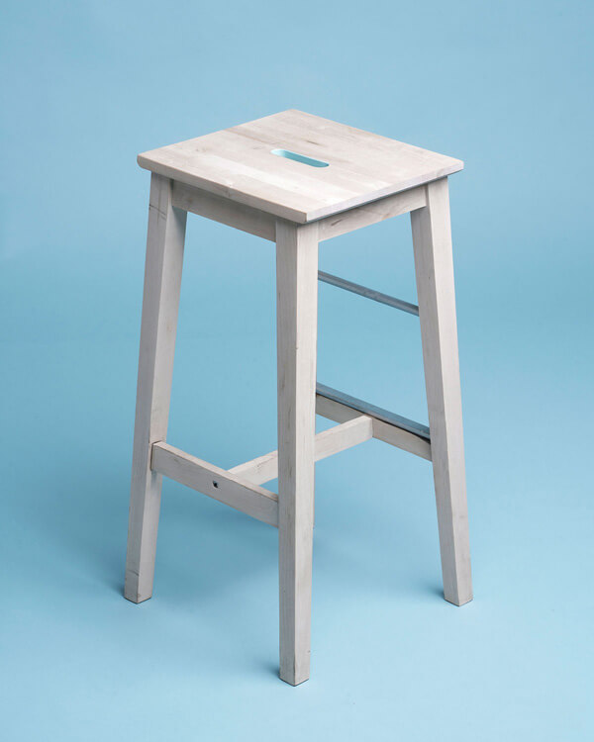



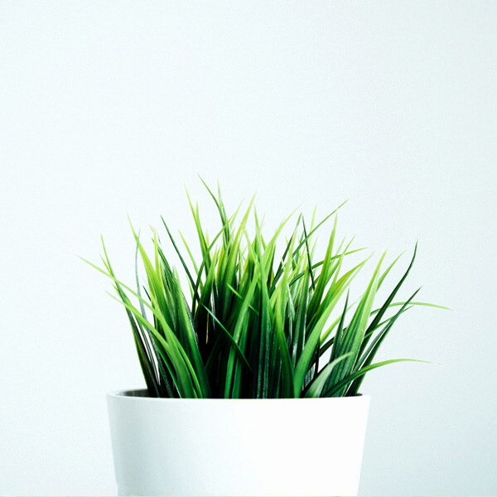





### **CONTACT US**

# **Reach out for a new project or just say hello**

### **SEND US A MESSAGE**

Top of Form







SUBMIT

Bottom of Form

### **CONTACT INFO**

##### **Where to Find Us**

14/41A, Ravindra Plaza,

Opposite Sahara States,

Jankipuram, Lucknow-226021

##### **Email Us At**

laamikadesignstudio@gmail.com

##### **Call Us At**

Mobile: (+91)7991261766

Proin eget tortor risus. Mauris blandit aliquet elit, eget tincidunt nibh pulvinar a. Praesent sapien massa, convallis a pellentesque nec, egestas non nisi. Mauris blandit aliquet elit, eget tincidunt nibh pulvinar a. Nulla porttitor accumsan tincidunt. Nulla porttitor accumsan tincidunt. Quaerat voluptas autem necessitatibus vitae aut.

#### **Get Notified**

Quia quo qui sed odit. Quaerat voluptas autem necessitatibus vitae aut non alias sed quia. Ut itaque enim optio ut excepturi deserunt iusto porro.

Top of Form



Bottom of Form

© Copyright Glint 2017 Site Template by [Colorlib](https://www.colorlib.com/)